Name:

ID:

VE230 Quiz 2  *11/06/2017*

**1)** If a North pole moves toward the loop from above the page, in what direction is the induced current?

1) Clockwise

2) Counterclockwise

3) No induced current

Ans: 2)

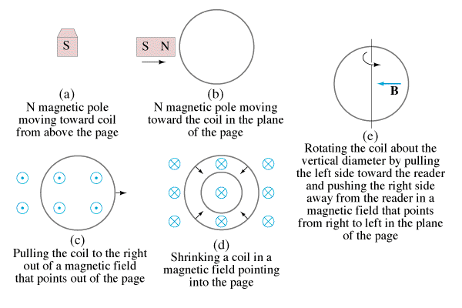

**2)** If a North pole moves toward the loop in the plane of the page, in what direction is the induced current?

1) Clockwise

2) Counterclockwise

3) No induced current

Ans: 3)



**3)** A wire loop is being pulled through a uniform magnetic field. What is the direction of the induced current?

1) Clockwise

2) Counterclockwise

3) No induced current

Ans: 3)

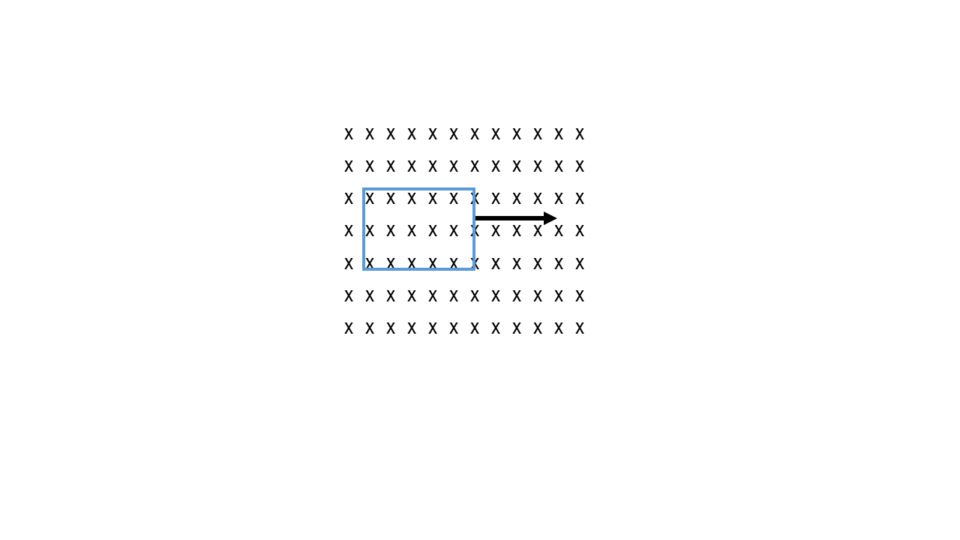

**4)** A wire loop is being pulled through a uniform magnetic field that suddenly ends. What is the direction of the induced current?

1) Clockwise

2) Counterclockwise

3) No induced current

Ans: 1)

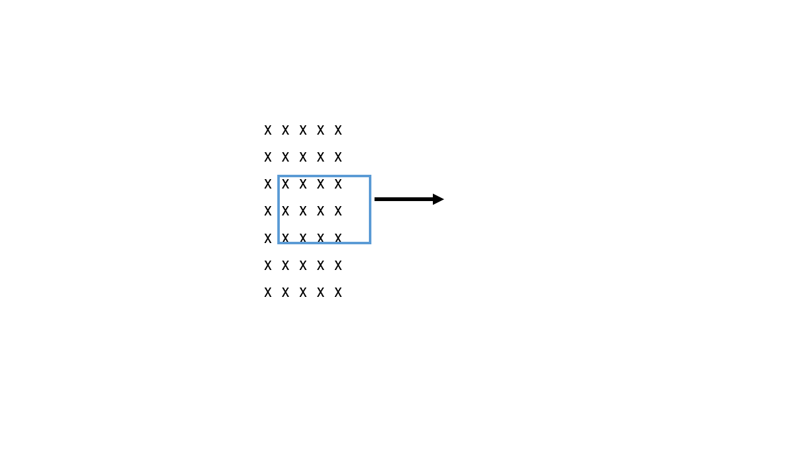

**5)** What is the direction of the induced current if the *B* field suddenly increases while the loop is in the region?

1) Clockwise

2) Counterclockwise

3) No induced current

Ans: 2)



**7)** If a coil is rotated as shown, in a magnetic field pointing to the left, in what direction is the induced current?

1) Clockwise

2) Counterclockwise

3) No induced current

Ans: 2)



**8)** Wire #1 (length *L*) forms a one-turn loop, and a bar magnet is dropped through. Wire #2 (length 2*L*) forms a two-turn loop, and the same magnet is dropped through. Compare the magnitude of the induced voltages in these two cases. (Here by voltage we mean emf)

1) *V1* > *V2*

2) *V1* < *V2*

3) *V1* = *V2* ≠ 0

4) *V1* = *V2* = 0

Ans: 2)

Compare the magnitude of the induced currents in these two cases.

1) *I1* > *I2*

2) *I1* < *I2*

3) *I1* = *I2* ≠ 0

4) *I1* = *I2* = 0

Ans: 2)

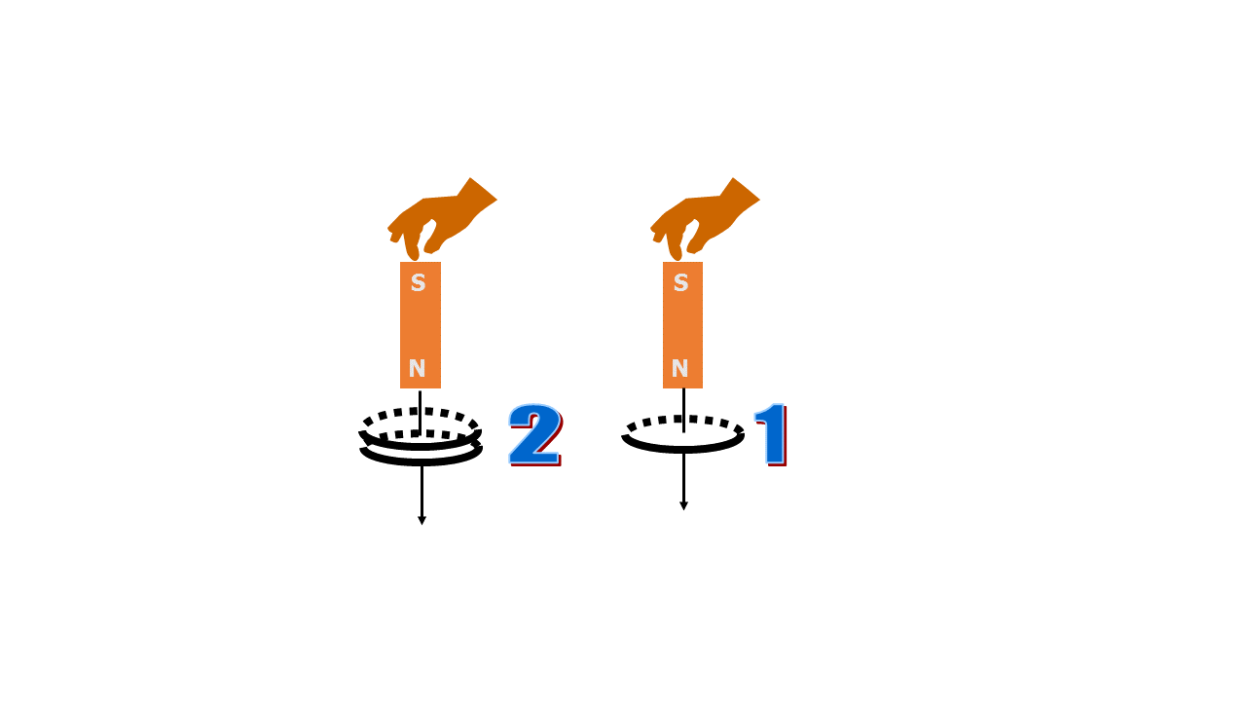

**9)** A bar magnet is held above the floor and dropped. In 1, there is nothing between the magnet and the floor. In 2, the magnet falls through a copper loop. How will the magnet in case 2 fall in comparison to case 1?

1) It will fall slower

2) It will fall faster

3) It will fall the same

Ans: 1)

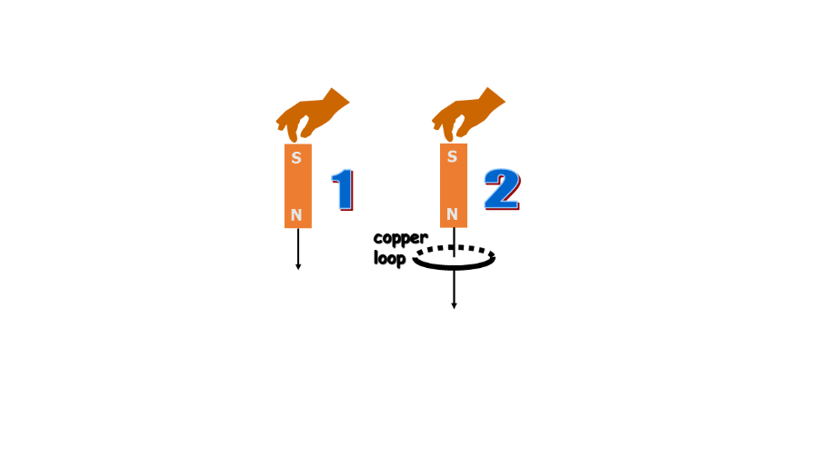

If there is induced current, doesn’t that cost energy? Where would that energy come from in case 2?

1) Induced current doesn’t need any energy

2) Energy conservation is violated in this case

3) There is less KE in case 2

4) There is more gravitational PE in case 2

Ans:3)

**11)** A wire loop is in a uniform magnetic field represented by black arrows. Current flows in the wire loop, as shown. What does the loop do?

(1) Moves to the right

(2) Moves up

(3) Remains motionless

(4) Rotates

(5) Moves out of the page

Ans: 4)

